`0 DISASTER NEWS
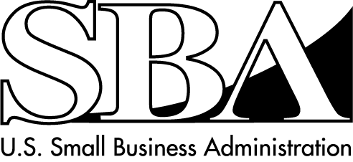
Loans for Businesses of all Sizes, Homeowners and Renters
SBA Disaster Assistance – Field Operations Center- East – 101 Marietta Street, NW, Suite 700, Atlanta, GA 30303
_________________________________________________________________________________________________________________________________
Release Date: Oct. 28, 2015 Contact: Michael Lampton
Release Number: 16-034, SC 14495/14496 Email: Michael.Lampton@sba.gov
Phone: (404) 331-0333

SBA Opens Business Recovery Center in Sumter County
ATLANTA – The U.S. Small Business Administration announced the opening of a Business Recovery Center, Thursday, Oct. 29 to assist businesses in applying for low interest disaster loans. These loans are made available due to the SBA disaster declaration as a result of severe storms and flooding on Oct. 1-23, 2015 in South Carolina.

The disaster declaration covers Bamberg, Berkeley, Calhoun, Charleston, Clarendon, Colleton, Darlington, Dorchester, Fairfield, Florence, Georgetown, Greenwood, Horry, Kershaw, Lee, Lexington, Marion, Newberry, Orangeburg, Richland, Sumter and Williamsburg counties in South Carolina which are eligible for both Physical and Economic Injury Disaster Loans from the SBA. Small businesses and most private nonprofit organizations in the following adjacent counties are eligible to apply only for SBA Economic Injury Disaster Loans: Abbeville, Aiken, Allendale, Barnwell, Beaufort, Chester, Chesterfield, Dillon, Edgefield, Hampton, Lancaster, Laurens, Marlboro, McCormick, Saluda and Union counties in South Carolina; Brunswick, Columbus and Robeson counties in North Carolina.

The Center is located and opening as indicated below, until further notice:

Sumter County
Sumter County Civic Center
700 W Liberty Street
Sumter, SC 29150
Opens: Thursday, Oct. 29 at 9 a.m.
Hours: 9 a.m. to 5 p.m., weekdays

“SBA’s Customer Service Representatives will be available at the Center to provide program information and assistance in completing disaster loan applications,” said Frank Skaggs, director of SBA Field Operations Center East.

Additional information on the disaster loan program may be obtained by calling SBA’s Customer Service Center at 800-659-2955 (800-877-8339 for the deaf and hard-of-hearing) or by sending an email to disastercustomerservice@sba.gov. Loan applications can be downloaded from www.sba.gov.

Applicants may apply online using the Electronic Loan Application (ELA) via SBA’s secure website at https://disasterloan.sba.gov/ela.

The filing deadline to return applications for physical property damage is December 4, 2015.
The deadline to return economic injury applications is July 5, 2016.

# # #

For more information about the SBA’s Disaster Loan Program, visit our website at www.sba.gov/disaster.

